- Create a customized Docker image using a Dockerfile.

Steps Performed:

1. Created a working directory
You created a new directory named docker in the root user’s home location.
mkdir docker

2. Moved into the directory
You navigated into the newly created directory.
cd docker
3. Verified directory contents
You listed the contents to confirm the directory was empty.
ls
4. Created the Dockerfile
You created and opened a Dockerfile using the vi editor.
vi dockerfile

5. Added Dockerfile instructions
Inside the Dockerfile, you added the following logic:
•Used Amazon Linux as the base image
•Updated system packages
•Installed nginx
•Cleaned yum cache
•Created the nginx HTML directory
•Created index.html directly at /usr/share/nginx/html/
•Exposed port 80
•Configured nginx to run in foreground

FROM amazonlinux:latest
RUN yum update -y && \
yum install -y nginx && \
yum clean all
RUN mkdir -p /usr/share/nginx/html
RUN echo "<h1>Hello from Nginx Docker</h1>" > /usr/share/nginx/html/index.html

EXPOSE 80

CMD ["nginx", "-g", "daemon off;"]
You saved and exited the file.

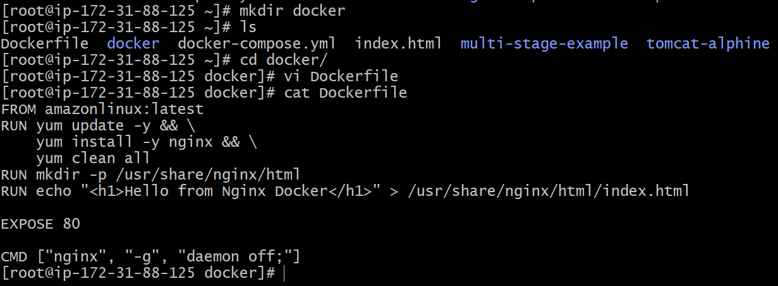

6. Built the Docker image
You built a Docker image named sample-nginx.
docker build -t sample-nginx:v1 .

During this step:
•Docker pulled the amazonlinux:latest image
•Installed nginx successfully
•Executed all Dockerfile steps
•Created intermediate layers
•Built the final image

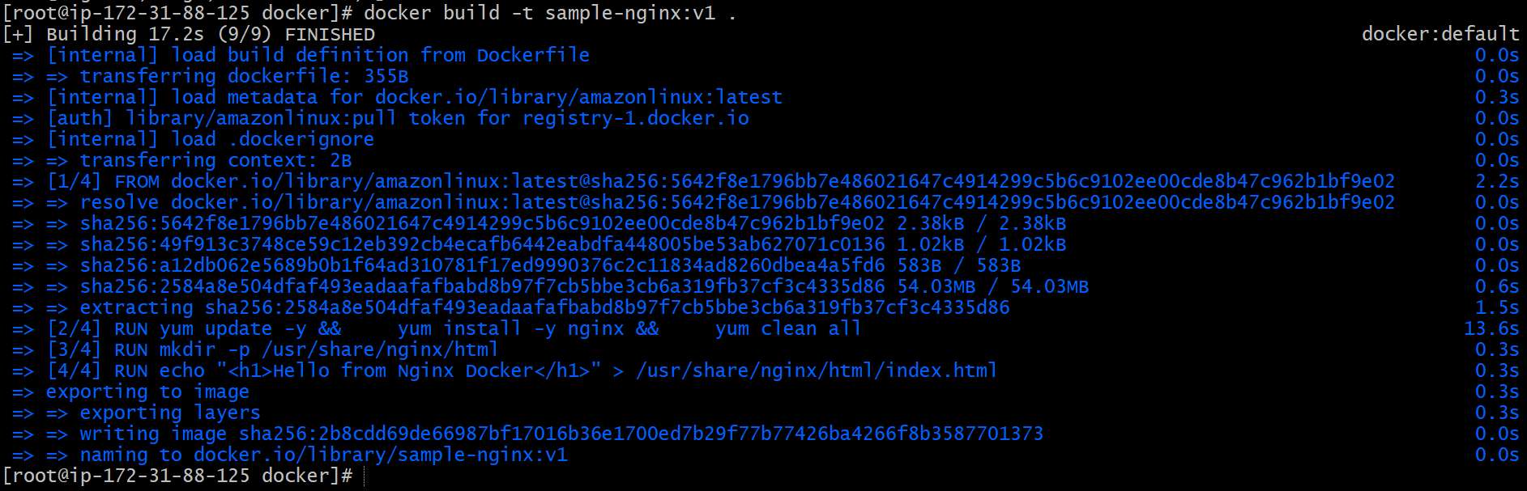

7. Image build completed successfully
Docker displayed:
Successfully built 0cb2b346ccaf
Successfully tagged sample-nginx:latest
This confirms the image was created without errors.
8. Verified the Docker image
You listed Docker images to confirm creation.
docker images
Output showed:
•Repository: sample-nginx
•Tag: v1
•Image ID: 2b8cd
•Size: ~213 MB

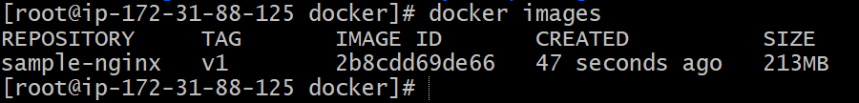

9. Ran the Docker container
You started a container from the previously built image sample-nginx and mapped host port 85 to container port 80.
docker run -itd -p 85:80 sample-nginx:v1
What happened here:
•-i → interactive mode
•-t → allocates terminal
•-d → runs container in background
•-p 85:80 → host port 85 mapped to nginx port 80
•sample-nginx → image name
Docker returned a container ID, confirming the container started successfully.

10. Verified running container
You checked the running containers using:
docker ps
Output confirmed:
•Container is running
•Image used: sample-nginx
•Command: nginx -g daemon off;
•Status: Up
•Port mapping: 0.0.0.0:85 -> 80/tcp
•Container name auto-generated (example: magical_swirl)

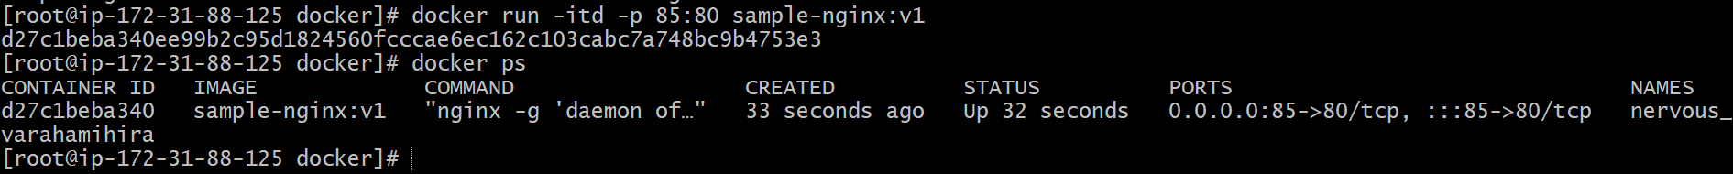

11. Accessed application from browser
You opened a browser and accessed the application using the public IP and port:
http://<ec2-public-ip>:85

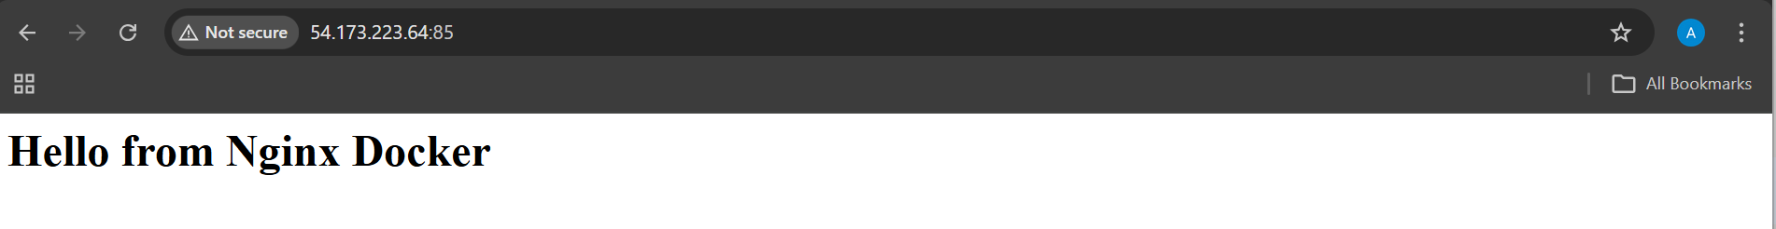

- Push the image to Docker Hub.

Steps Performed (Tagging & Pushing to Docker Hub)

1. Tagged the local Docker image
You tagged the existing local image sample-nginx:latest with your Docker Hub username so it can be pushed to Docker Hub.
docker tag sample-nginx:v1 aniketh1234/amazon-nginx:v1
This created a new tag pointing to the same image ID.

2. Verified the image tagging
You listed the Docker images to confirm the new tag exists.
docker images
The output showed:
- sample-nginx:latest
- aniketh1234/amazon-nginx:v1
Both had the same IMAGE ID, confirming correct tagging.

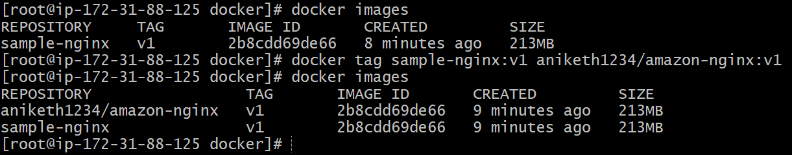

3. Pushed the image to Docker Hub
You pushed the tagged image to Docker Hub.
docker push aniketh1234/amazon-nginx:v1
Docker:
- Uploaded required layers
- Skipped existing layers

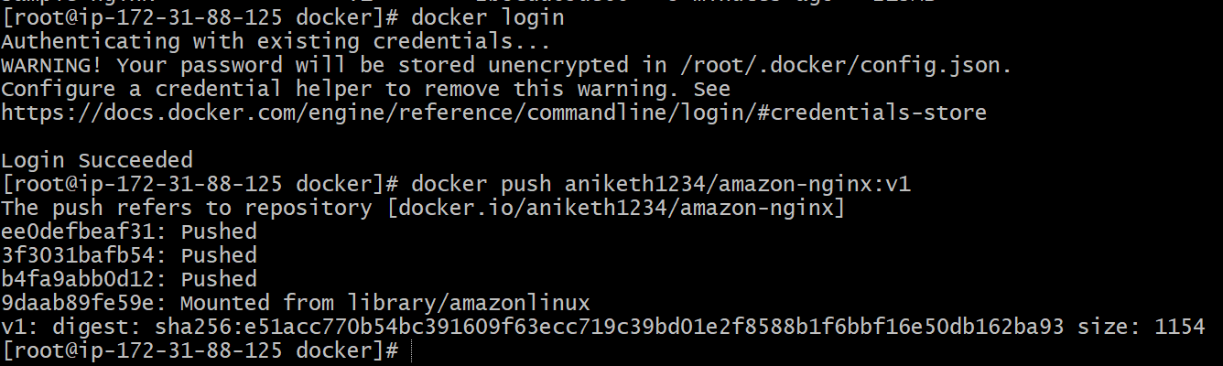

4. Verified image on Docker Hub
You opened Docker Hub (via Docker Desktop → My Hub) and verified:
- Repository name: krishnav7090/sample-nginx
- Tag: latest
- Image visible and available for pull

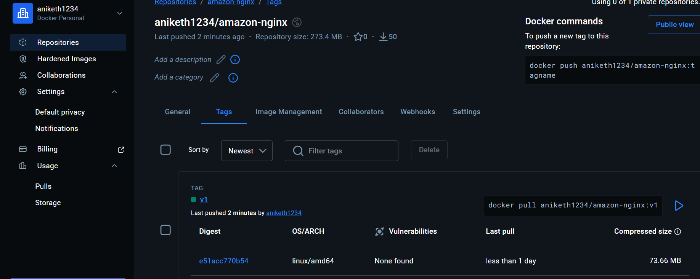

- Push the same image to Amazon ECR.

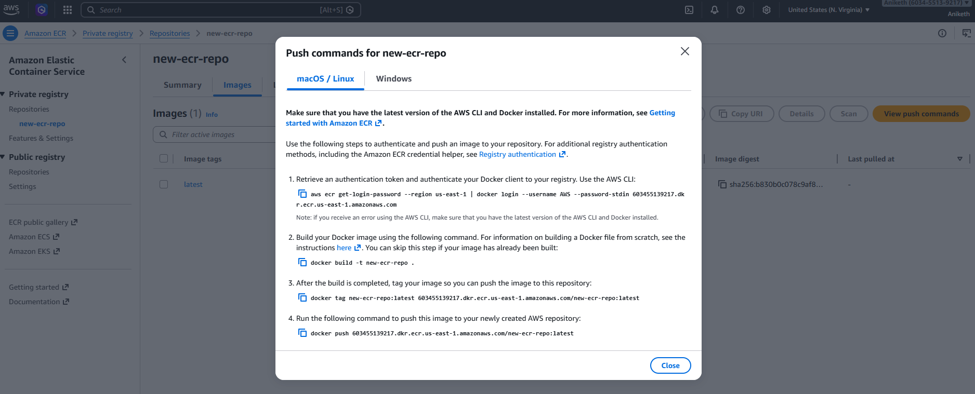

Steps Performed (Pushing Image to Amazon ECR)

1. Logged in to Amazon ECR
You authenticated Docker with Amazon ECR using AWS CLI.
aws ecr get-login-password --region us-east-1 | docker login --username AWS --password-stdin 603455139217.dkr.ecr.us-east-1.amazonaws.com

Result:
- Login succeeded
- Docker is now authorized to push images to ECR

2. Tagged the local Docker image for ECR
You tagged the existing local image sample-nginx:latest with the Amazon ECR repository URI.
docker tag sample-nginx:v1 603455139217.dkr.ecr.us-east-1.amazonaws.com/new-ecr-repo:v1
This created a new tag pointing to the same image ID.
3. Verified the image tags
You listed Docker images to confirm tagging.
docker images
Confirmed:
- sample-nginx:latest
- 603455139217.dkr.ecr.us-east-1.amazonaws.com/sample-nginx:latest
Both have the same IMAGE ID, proving it is the same image.

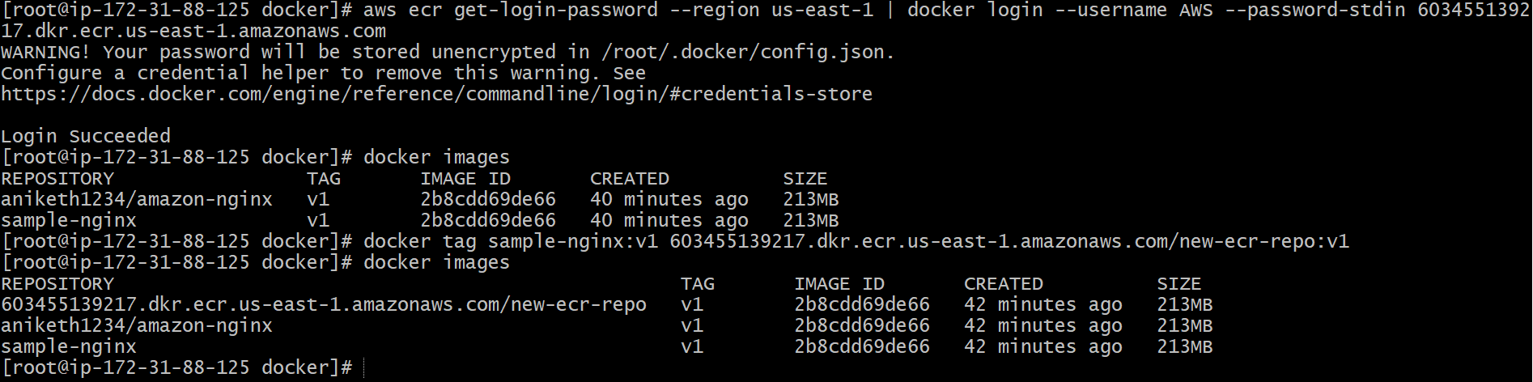

4. Pushed the image to Amazon ECR
You pushed the tagged image to the newly created ECR repository.
docker push 603455139217.dkr.ecr.us-east-1.amazonaws.com/new-ecr-repo:v1
Docker:
- Uploaded image layers
- Reused existing layers where applicable
- Generated image digest
Push completed successfully.

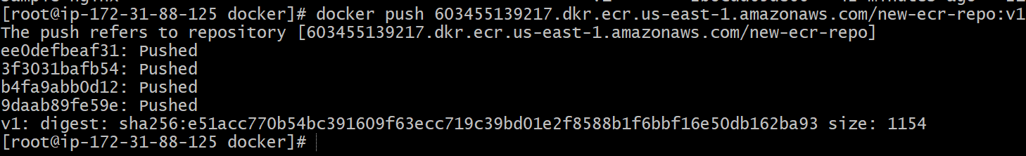

5. Verified the image in AWS Console
You opened the AWS Console and navigated to:
Amazon ECR → Private registry → Repositories
Image successfully stored in ECR

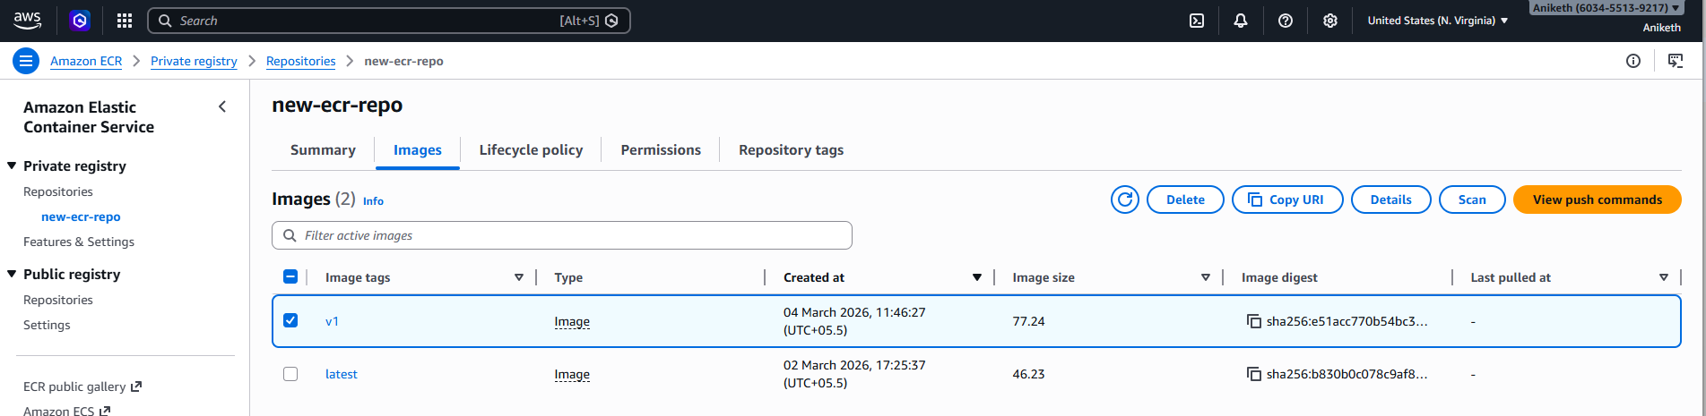

- Provision one EC2 instance using Terraform and install Jenkins.

Steps performed:
1. Project Setup
- Created a Terraform project directory aws_instance
- Added three Terraform files only:
  - main.tf
  - variable.tf
  - outputs.tf
2. Variable Configuration (variable.tf)
- Defined all required variables with default values:
  - AWS region: us-east-1
  - AMI ID: ami-0f3caa1cf4417e51b
  - Instance type: c7i-flex.large
  - Key pair name: logical
Avoided using terraform.tfvars by using defaults.

variable.tf script :
variable "region" {
description = "The AWS region to deploy the Jenkins server"
type = string
default = "us-east-1"
}
variable "ami_id" {
description = "The AMI ID for the Jenkins server"
type = string
default = "ami-0f3caa1cf4417e51b"
}
variable "instance_type" {
description = "The instance type for the Jenkins server"
type = string
default = "c7i-flex.large"
}

variable "key_name" {
description = "The name of the SSH key pair to access the Jenkins server"
type = string
default = "logical"
}

3. EC2 Provisioning (main.tf)
- Configured AWS provider using the region variable.
- Created an EC2 instance using:
  - Amazon Linux 2 AMI
  - Custom instance type
  - Existing key pair
  - Existing default security group
- Increased root volume size to 20 GB (gp3).
- Used user_data to automate Jenkins installation.
4. Jenkins Installation via User Data
The following actions were executed automatically during instance boot:
- Updated system packages.
- Installed Java 17 (Amazon Corretto).
- Added Jenkins official YUM repository.
- Imported Jenkins GPG key.
- Installed Jenkins package.
- Explicitly configured Jenkins to use Java:
  - Set JENKINS_JAVA_CMD="/usr/bin/java".
- Reloaded systemd and enabled Jenkins service.
- Started Jenkins service successfully.

main.tf script:

provider "aws" {
region = var.region
}

resource "aws_instance" "jenkins_server" {
ami = var.ami_id
instance_type = var.instance_type
key_name = var.key_name

root_block_device {
volume_size = 20
volume_type = "gp3"
}

user_data = <<-EOF
#!/bin/bash
yum update -y
# Install Java 17
yum install java-17-amazon-corretto -y
# Add Jenkins repository
wget -O /etc/yum.repos.d/jenkins.repo https://pkg.jenkins.io/redhat-stable/jenkins.repo
rpm --import https://pkg.jenkins.io/redhat-stable/jenkins.io.key
# Install Jenkins
yum install jenkins -y
systemctl enable jenkins
systemctl start jenkins
EOF
tags = {
Name = "Terraform-Jenkins-Server"
}
}

5. Terraform Outputs (outputs.tf)
- Configured outputs to display:
  - Jenkins public ip
  - Jenkins Web URL (http://<public_ip>:8080)
outputs.tf script:

output "jenkins_public_ip" {
value = aws_instance.jenkins_server.public_ip
}
output "jenkins_url" {
value = "http://${aws_instance.jenkins_server.public_ip}:8080"
}

6. Terraform Execution
- Ran the following Terraform commands in sequence:
- terraform init
- terraform validate
- terraform plan
- terraform apply
- Confirmed the apply with yes.
- Terraform successfully created the EC2 instance.

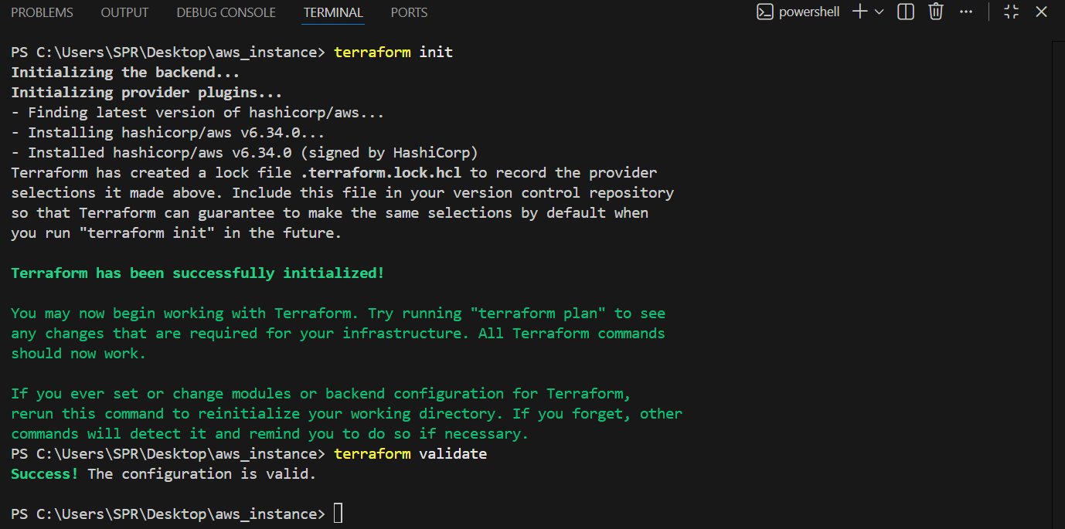

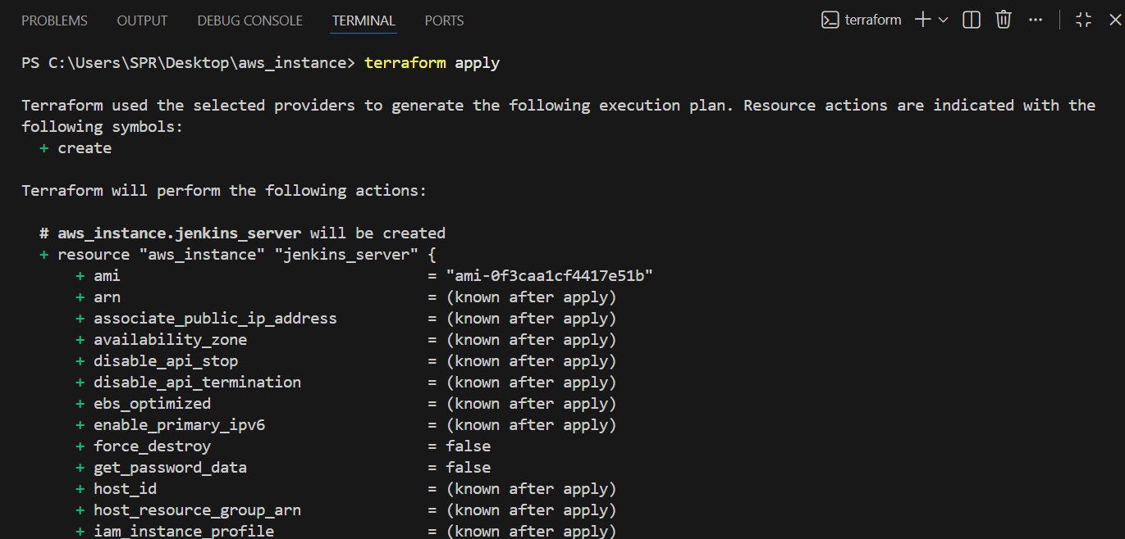
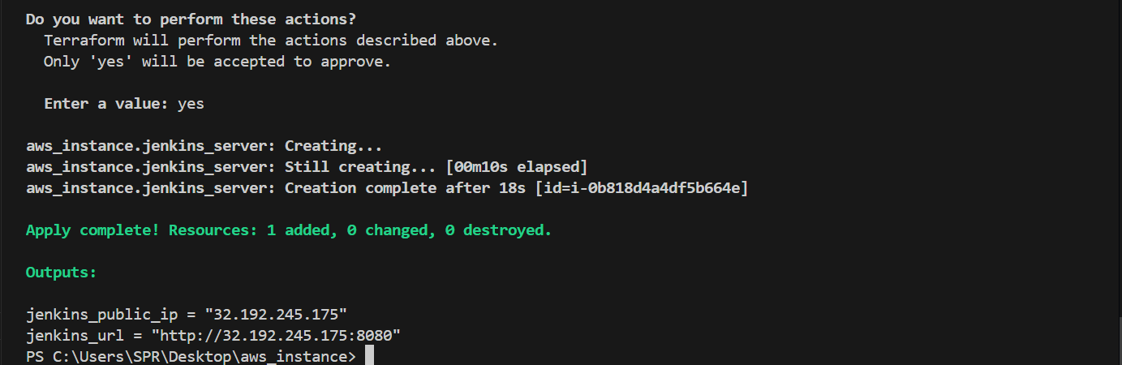

7. Verification in AWS Console
- Verified EC2 instance state as Running.
- Confirmed instance type, public IP, and tags.

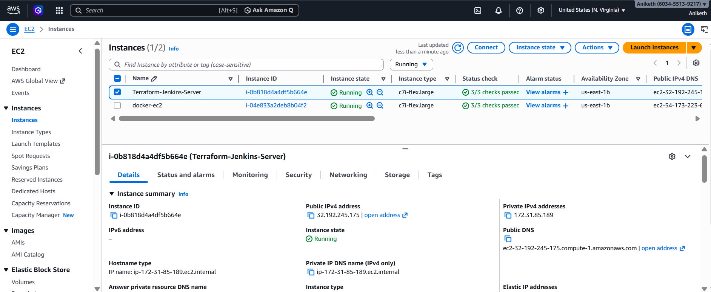

8. Jenkins Service Validation
- Connected to the instance using SSH with logical.pem
- Checked Jenkins service status:
- systemctl status jenkins
- Verified Jenkins service is active (running).

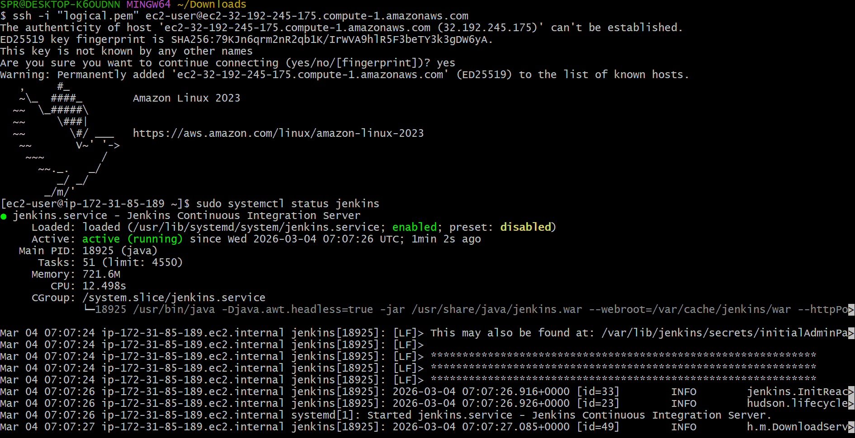

9. Jenkins Initial Setup
- Retrieved Jenkins initial admin password:
- cat /var/lib/jenkins/secrets/initialAdminPassword
- Accessed Jenkins UI using the public IP on port 8080.
- Completed Jenkins unlock and setup wizard.
- Reached the Jenkins dashboard successfully.

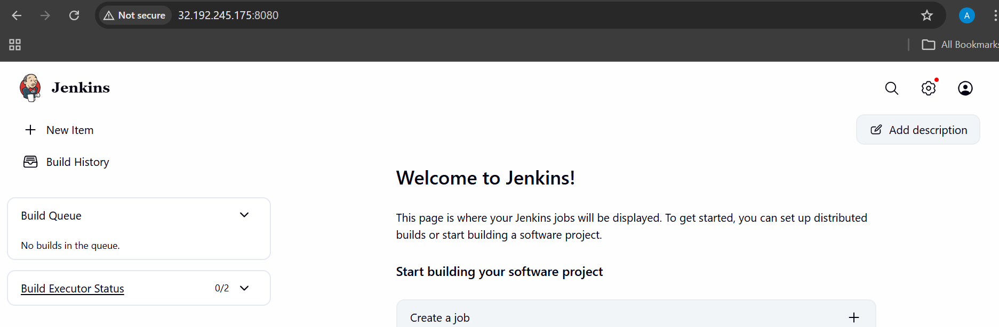

- Create one Jenkins job to build and push the Docker image to Docker Hub.
Source: https://github.com/betawins/Python-app.git

Step 1: Install Required Tools on Jenkins Server

Make sure your Jenkins server has:

Install Docker

sudo yum update -y
sudo yum install git -y
sudo yum install maven -y
sudo yum install docker -y
sudo systemctl start docker
sudo systemctl enable docker

Add Jenkins user to Docker group:

sudo usermod -aG docker jenkins
sudo systemctl restart jenkins

Install Jenkins Docker Plugin

Go to:

Manage Jenkins → Manage Plugins → Available Plugins

Install:

✅ Docker Pipeline
✅ Docker Commons
✅ Docker
✅ Git
✅ pipeline

Step 2: Create Docker Hub Credentials in Jenkins

1. Go to:
Manage Jenkins → Manage Credentials
2. Click:
(Global) → Add Credentials
3. Select:
Username with password
4. Enter:
* Username: your Docker Hub username
* Password: your Docker Hub password
* ID: `dockerhub`
* Description: Docker Hub Credentials

Click **Save**.

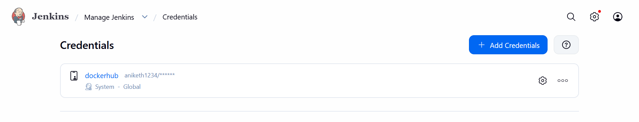

Step 4: Create Jenkins Pipeline Job

1. Go to Jenkins Dashboard
2. Click **New Item**
3. Enter name → `docker-pipeline`
4. Select → **Pipeline**
5. Click OK

Step 5: Add Jenkinsfile (Pipeline Script)
Go to:
Pipeline → Definition → Pipeline Script

Paste this:
pipeline {
agent any

environment {
DOCKER_IMAGE = "aniketh1234/python-app"
DOCKER_TAG = "latest"
}

stages {

stage('Checkout Code') {
steps {
git branch: 'main',
url: 'https://github.com/betawins/Python-app.git'
}
}

stage('Build Docker Image') {
steps {
sh 'docker build -t $DOCKER_IMAGE:$DOCKER_TAG .'
}
}

stage('Login to Docker Hub') {
steps {
withCredentials([usernamePassword(
credentialsId: 'dockerhub',
usernameVariable: 'DOCKER_USER',
passwordVariable: 'DOCKER_PASS'
)]) {
sh '''
echo $DOCKER_PASS | docker login -u $DOCKER_USER --password-stdin
'''
}
}
}

stage('Push Docker Image') {
steps {
sh 'docker push $DOCKER_IMAGE:$DOCKER_TAG'
}
}
}

post {
success {
echo "Image pushed successfully 🚀"
}
failure {
echo "Pipeline failed ❌"
}
}
}

Step 6: Build the Pipeline

Click:
Build Now

If successful, you will see:
Successfully pushed yourdockerhubusername/myapp:latest

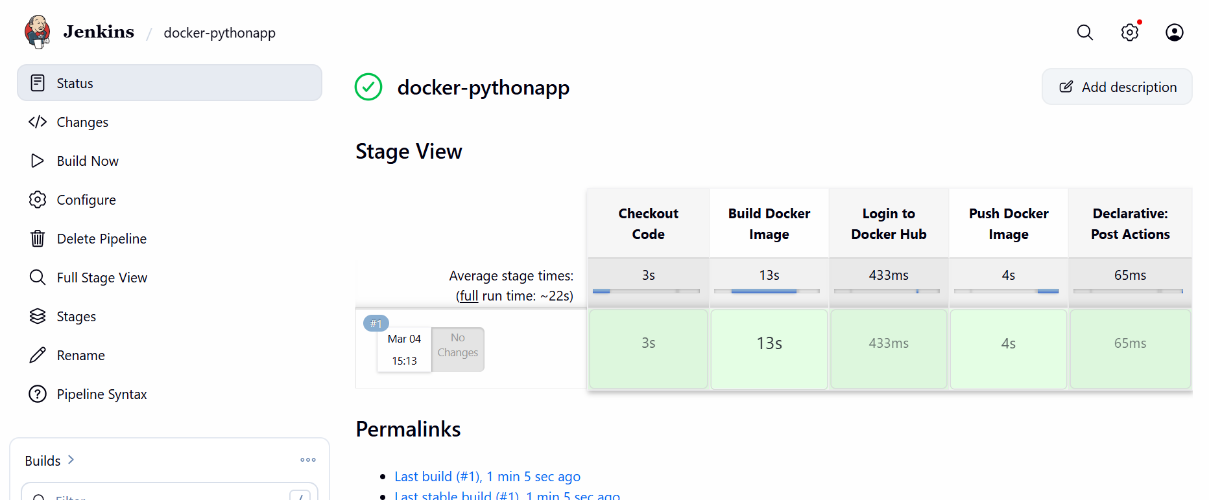

Step 7 : Verified Image in DockerHub
- Logged into Docker Desktop / DockerHub
- Confirmed image:
- Aniketh1234/python-app
- Image successfully pushed and visible
Final Outcome
- Jenkins successfully:
  - Pulled code from GitHub
  - Built Docker image
  - Authenticated to DockerHub
  - Pushed image to DockerHub registry
You’ve essentially completed a CI pipeline: GitHub → Jenkins → DockerHub

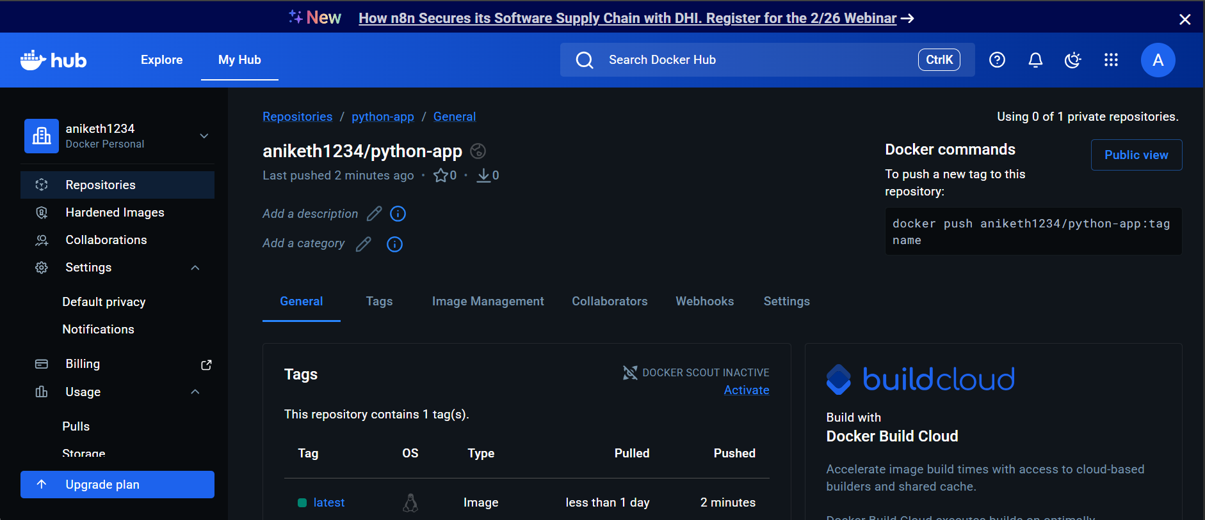

- open_file_folder: Source Codes: https://github.com/betawins/docker-tasks.git

- From the frontend source code, write a Dockerfile, build a Docker image, run it, and push that image to your Docker registry.

Steps performed:
1. Cloned the GitHub repository:
git clone https://github.com/betawins/docker-tasks.git

2. Listed files and entered the cloned repository:
ls
cd docker-tasks
cd Frontend_based_source

3.Verified repository contents:
ls
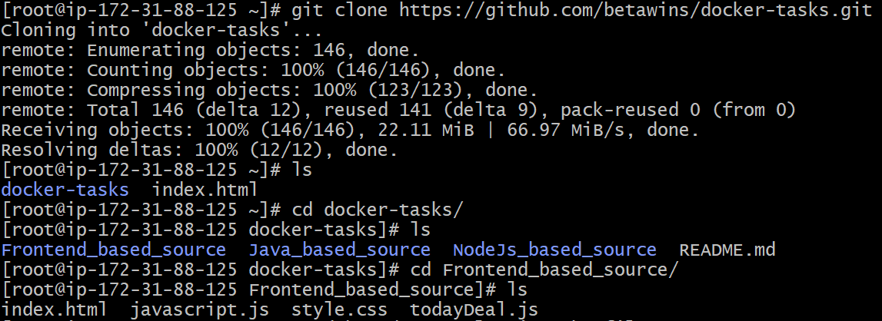

4.Created a Dockerfile:
vi Dockerfile
5.Added Dockerfile content using nginx:latest as base image, removed default nginx content, copied index.html, exposed port 80, and started nginx in foreground.

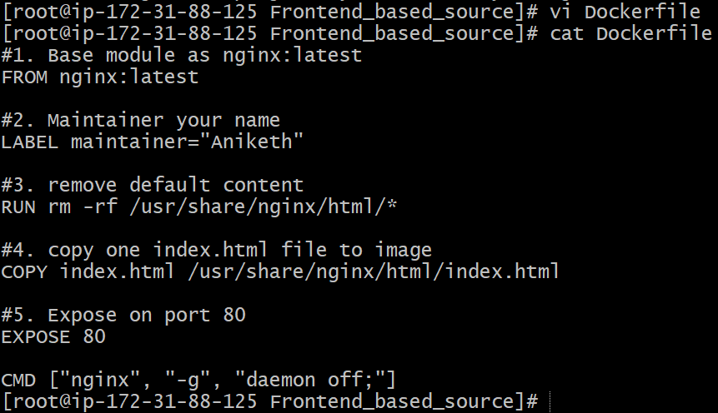

6.Created the frontend HTML file:
vi index.html
Index.html content :
<!DOCTYPE html>
<html lang="en">
<head>
<meta charset="UTF-8">
<meta name="viewport" content="width=device-width, initial-scale=1.0">
<title>Frontend App Running</title>

<style>
body{
margin:0;
height:100vh;
display:flex;
justify-content:center;
align-items:center;
font-family: Arial, Helvetica, sans-serif;
background: linear-gradient(135deg,#7b2ff7,#f107a3);
}

.container{
background:#4b184f;
padding:50px 80px;
border-radius:15px;
text-align:center;
color:white;
box-shadow:0 15px 30px rgba(0,0,0,0.3);
}

h1{
font-size:32px;
margin-bottom:15px;
}

p{
margin:6px 0;
font-size:16px;
color:#ddd;
}

.status{
display:inline-block;
margin-top:25px;
background:#2ecc71;
color:#000;
font-weight:bold;
padding:10px 22px;
border-radius:25px;
font-size:14px;
}
</style>

</head>

<body>

<div class="container">
<h1>Frontend App Running 🚀</h1>
<p>Deployed using Docker & NGINX</p>
<p>Hosted on AWS EC2</p>

<div class="status">
STATUS: SUCCESS
</div>
</div>

</body>
</html>

7.Verified files in directory:
Ls
8.Built the Docker image:
docker build -t aniketh1234/frontend-app:v1 .

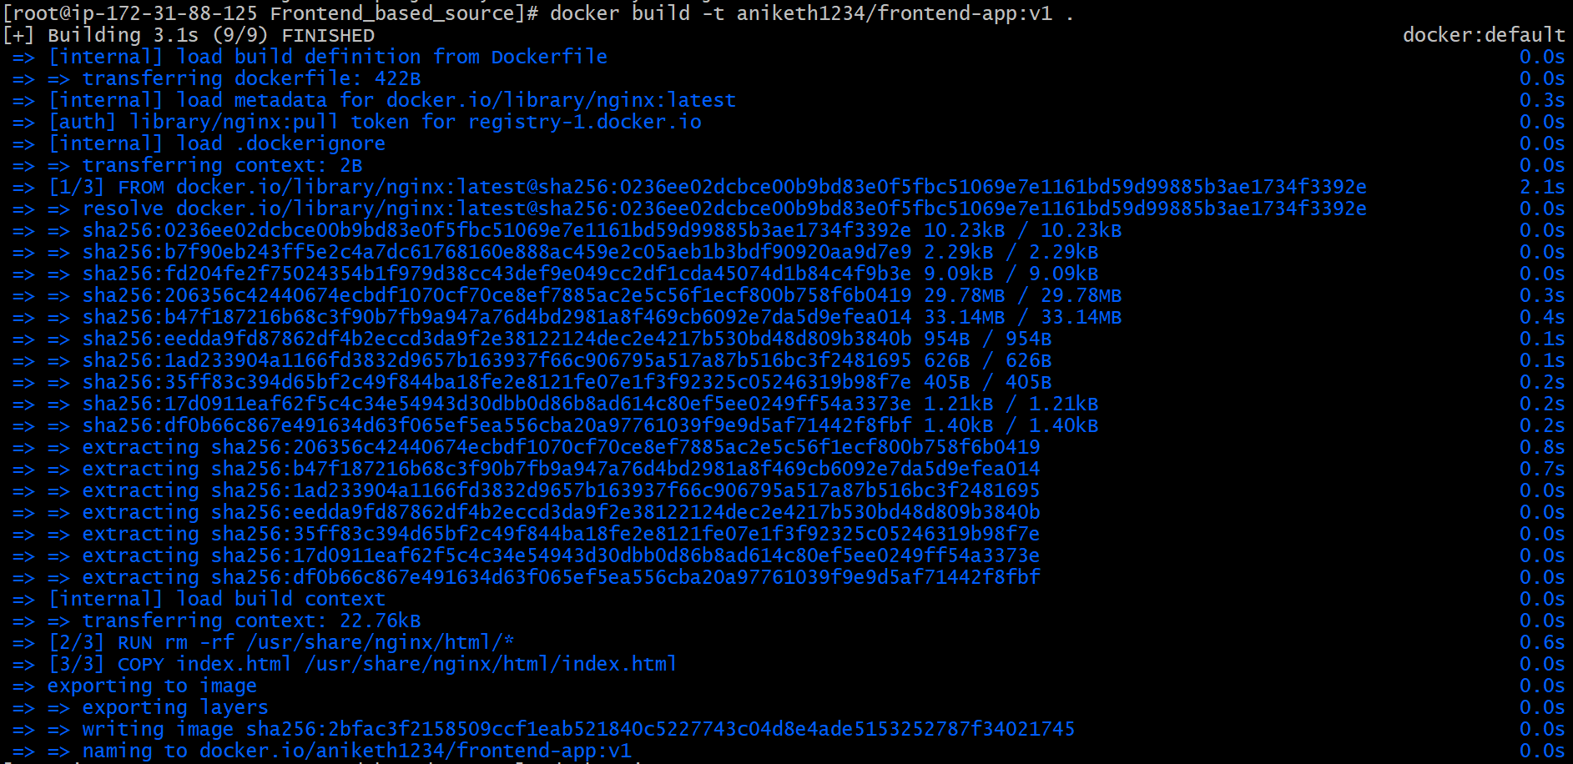

9.Confirmed image build completed successfully.
docker images

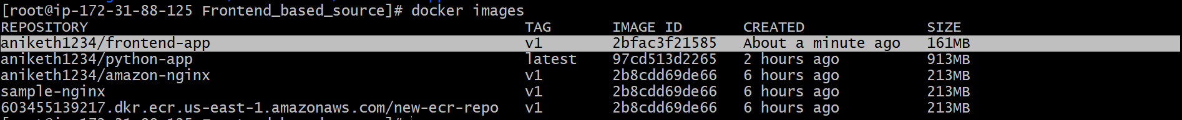
10.Ran the Docker container and mapped ports:
docker run -d -p 8089:80 aniketh1234/frontend-app:v1
11.Verified running containers:
docker ps
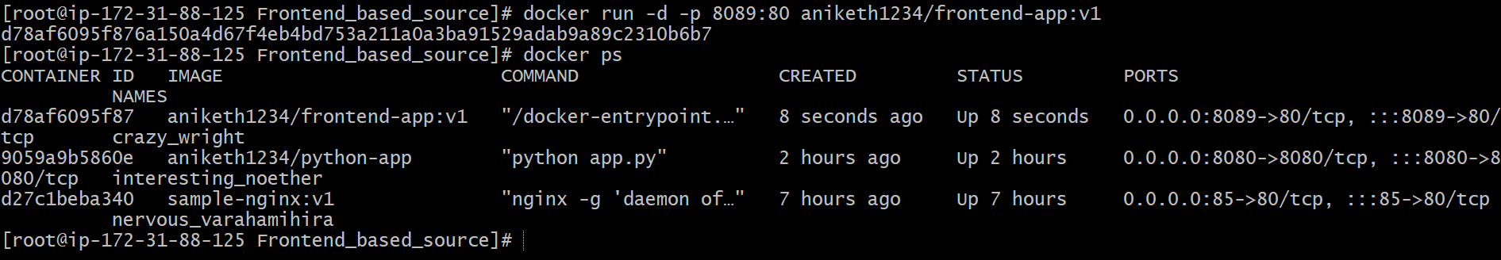
12.Accessed the application in browser using:
http://<EC2-Public-IP>:8089
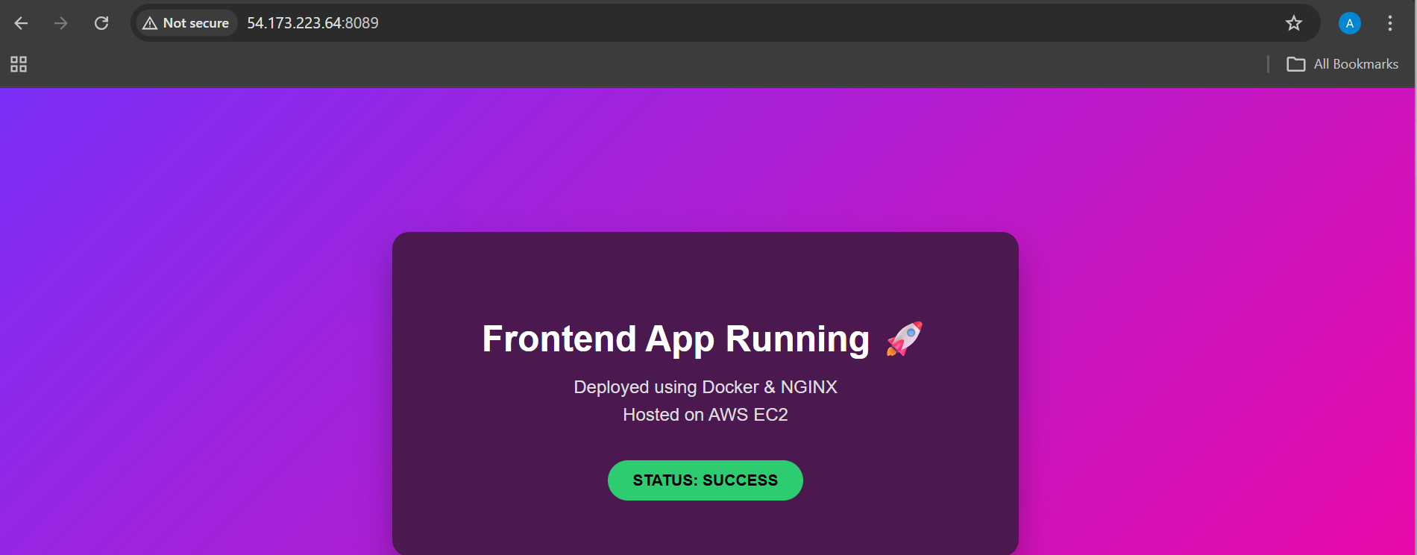
13.Logged in to Docker Hub:
docker login
14.Pushed the Docker image to Docker Hub:
docker push aniketh1234/frontend-app:v1

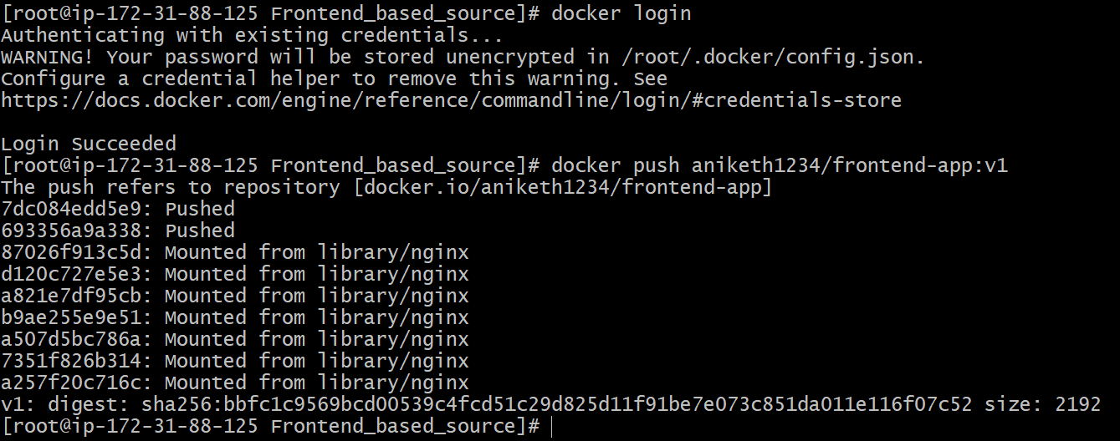

15.Verified the image is available in Docker Hub.
16.Opened Docker Desktop and confirmed the image appears under local images.

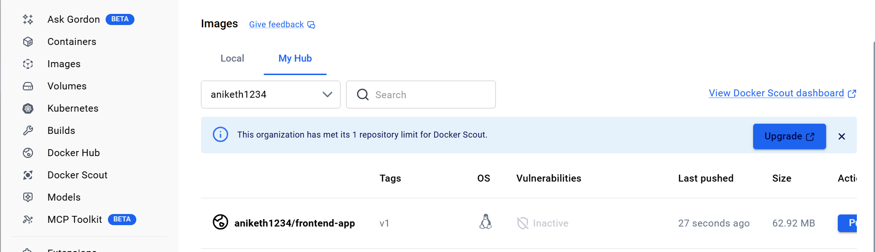

- From the Java-based source code, write a Dockerfile, build, run, and push the image to the Docker registry.

Steps performed:
1. Cloned the GitHub repository:
git clone https://github.com/betawins/docker-tasks.git

2. Listed files and entered the cloned repository:
ls
cd docker-tasks
cd Java_based_source

3.Verified repository contents:
ls
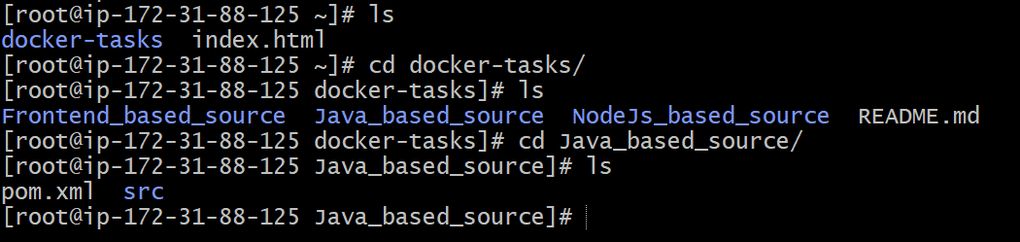

4.Created a Dockerfile:
vi Dockerfile

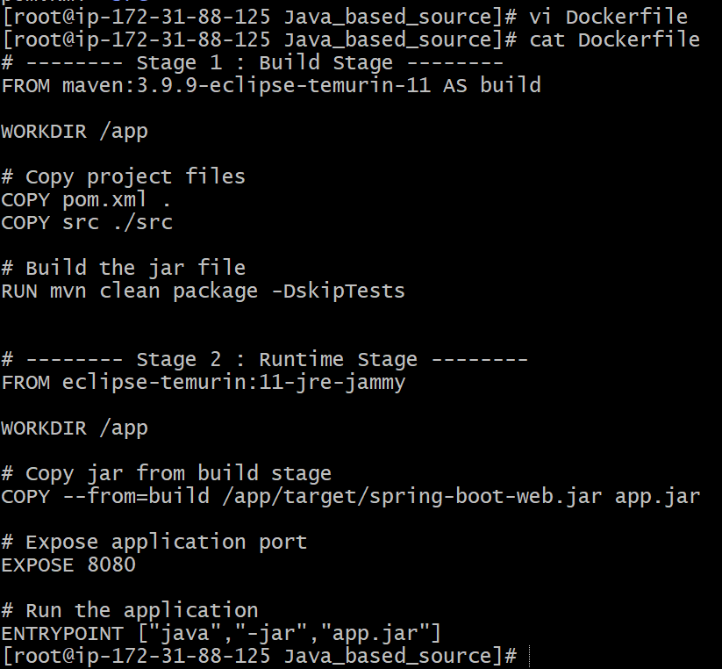

5.Built the Docker image:
docker build -t aniketh1234/java-based-app:v1 .
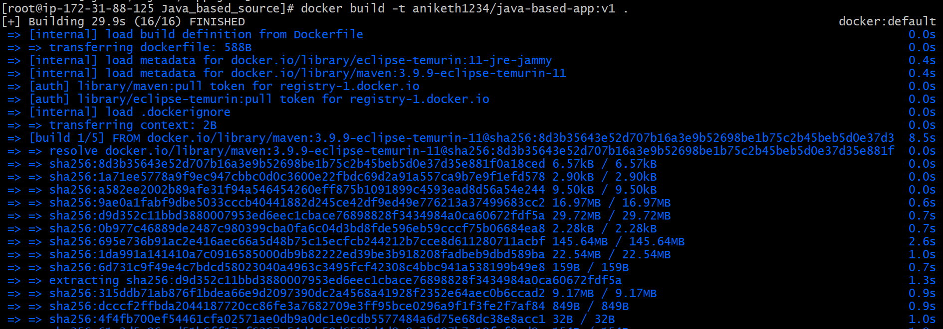
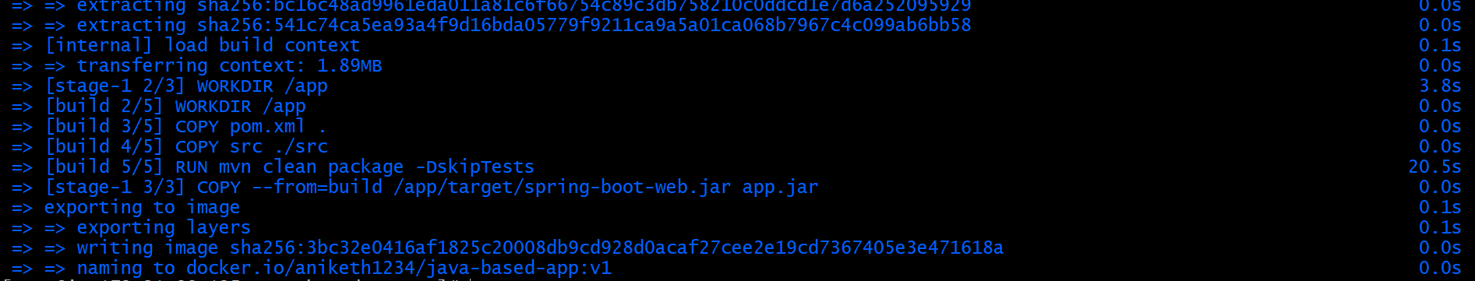

6.Confirmed image build completed successfully.
docker images

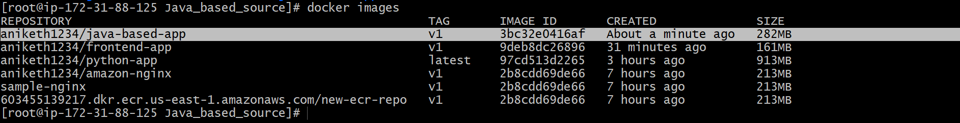
7.Ran the Docker container and mapped ports:
docker run -d -p 8086:8080 aniketh1234/java-based-app:v1
8.Verified running containers:
docker ps
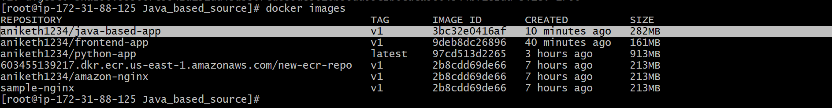

9.Accessed the application in browser using:
http://<EC2-Public-IP>:8086
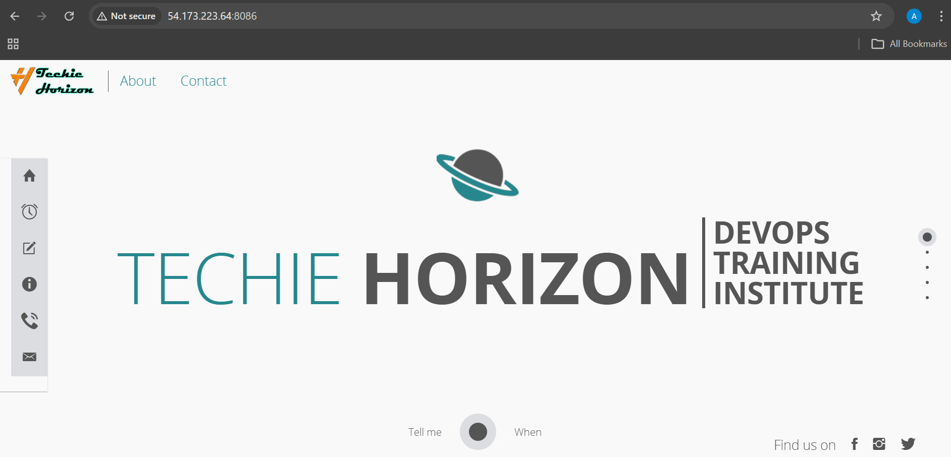
10.Logged in to Docker Hub:
docker login
11.Pushed the Docker image to Docker Hub:
docker push aniketh1234/java-based-app:v1

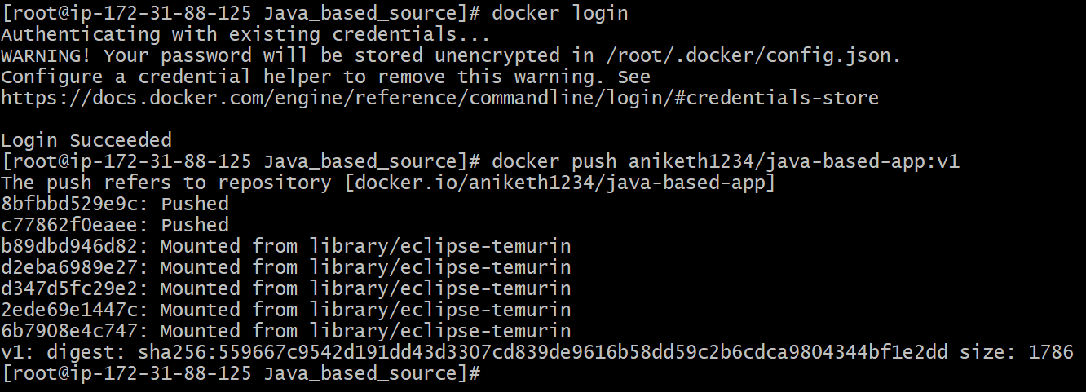

12.Verified the image is available in Docker Hub.
13.Opened Docker Desktop and confirmed the image appears under local images.

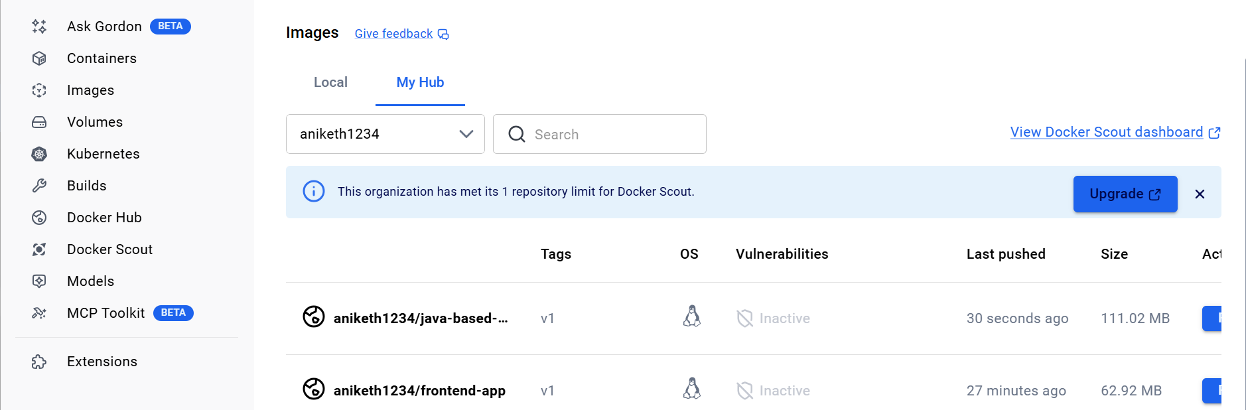

(c) From the Node.js-based source code, write a Dockerfile, build with tag v1, run, and push it to the Docker registry.

Steps performed:
1. Cloned the GitHub repository:
git clone https://github.com/betawins/docker-tasks.git

2. Listed files and entered the cloned repository:
ls
cd docker-tasks
cd Node_based_source

3.Verified repository contents:
ls
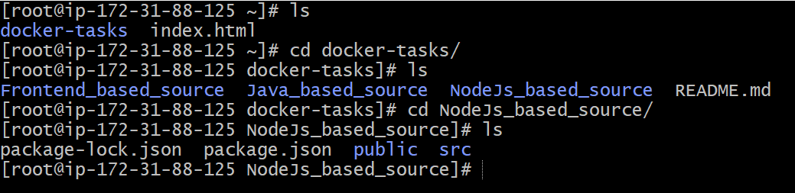

4.Created a Dockerfile:
vi Dockerfile
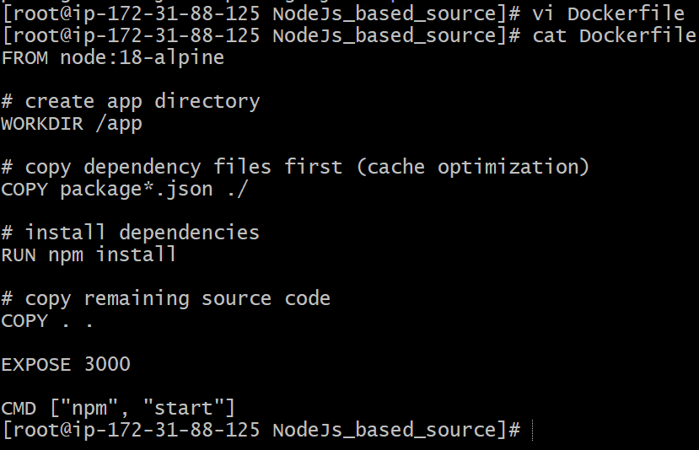

5.Built the Docker image:
docker build -t aniketh1234/node.js-based-app:v1 .

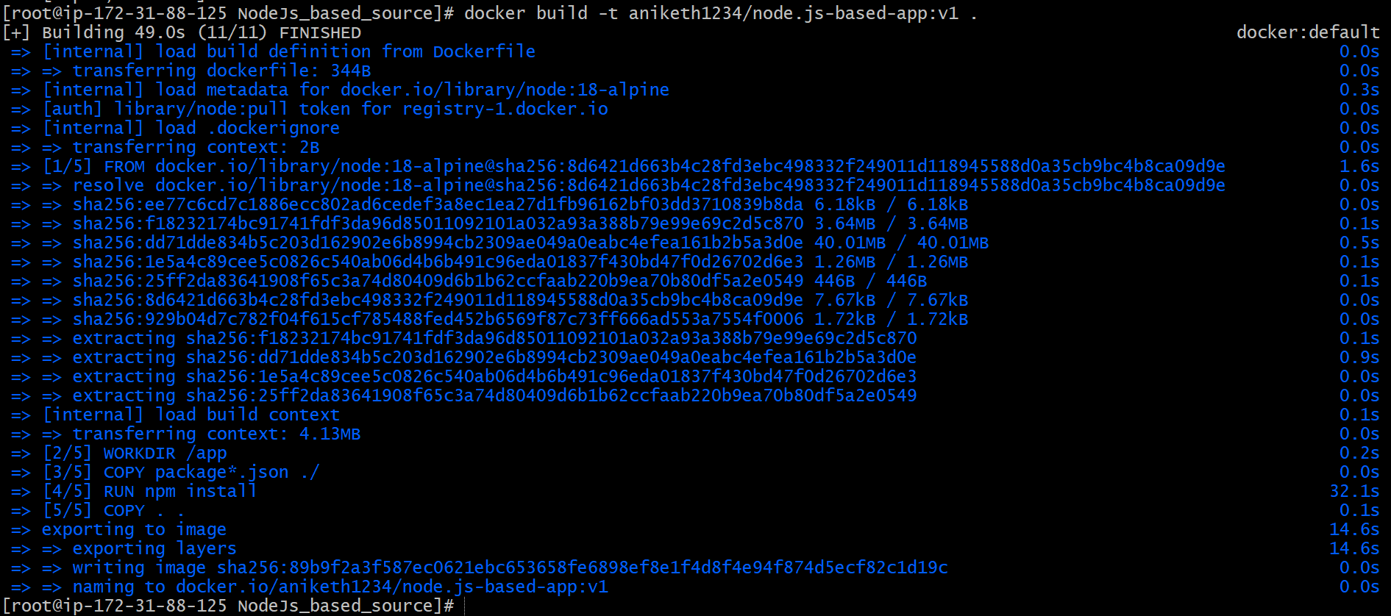

6.Confirmed image build completed successfully.
docker images

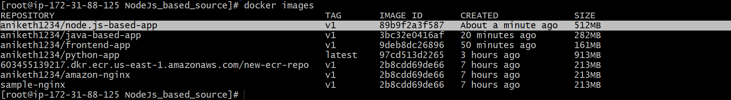

7.Ran the Docker container and mapped ports:
docker run -d -p 3000:3000 aniketh1234/node.js-based-app:v1
8.Verified running containers:
docker ps

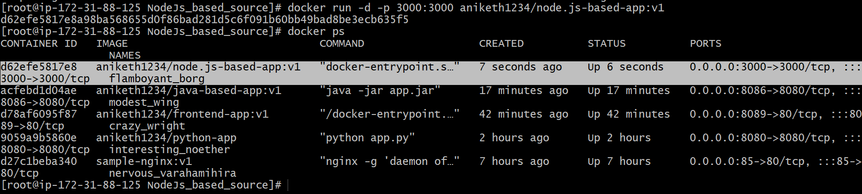

9.Accessed the application in browser using:
http://<EC2-Public-IP>:3000



10.Logged in to Docker Hub:
docker login
11.Pushed the Docker image to Docker Hub:
docker push aniketh1234/node.js-based-app:v1

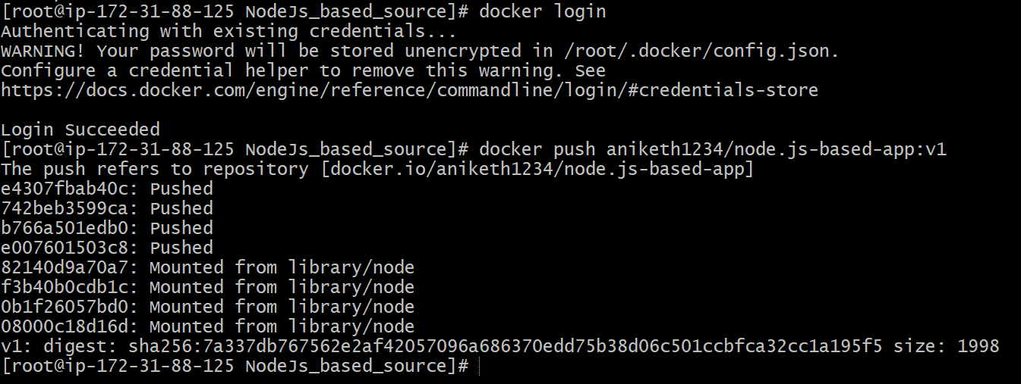

12.Verified the image is available in Docker Hub.
13.Opened Docker Desktop and confirmed the image appears under local images.

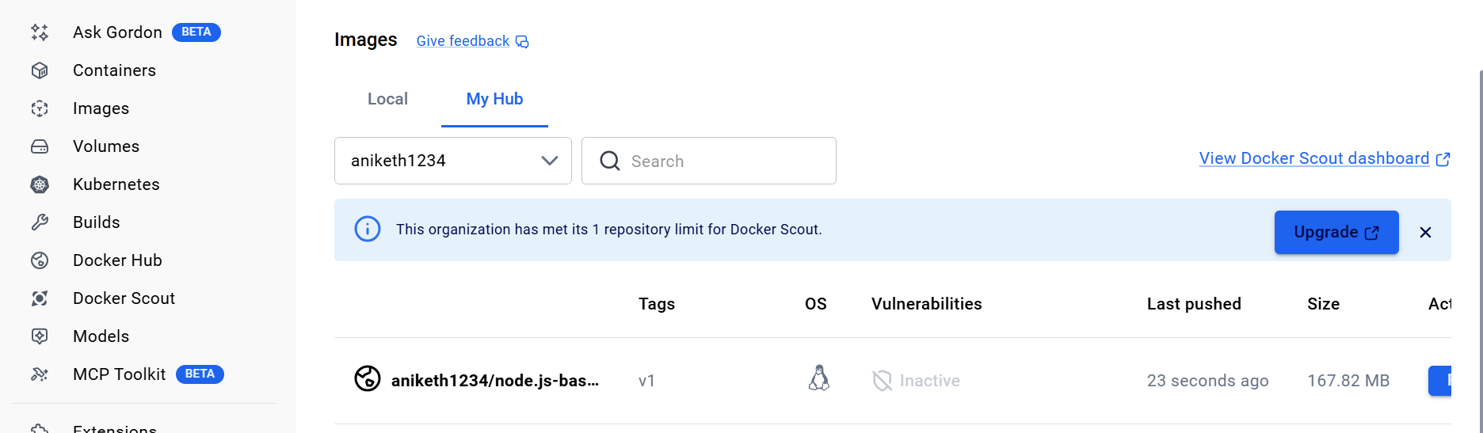

- Write a docker-compose file to set up WordPress with a MySQL database.

Step 1: Create a directory

mkdir wordpress-compose
cd wordpress-compose

Step 2: Create docker-compose file

vi docker-compose.yml

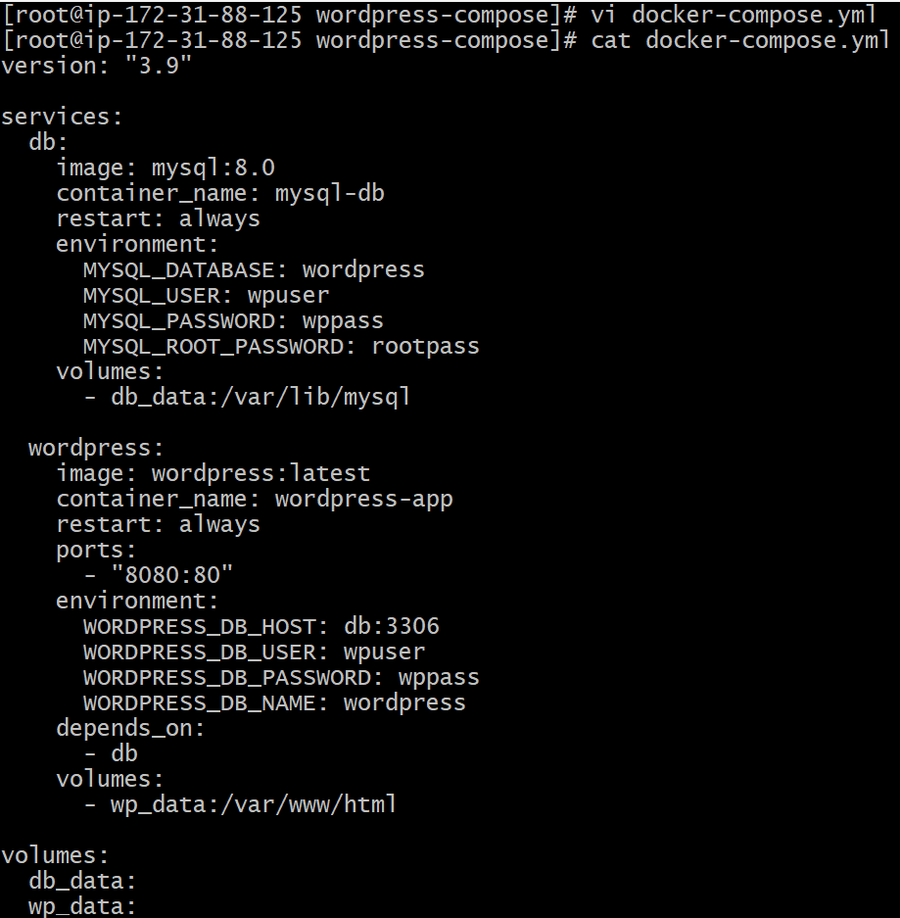

Step 3: Start containers

docker-compose up -d

Step 4: Verify containers

docker ps

You should see:

* wordpress-app
* wordpress-db

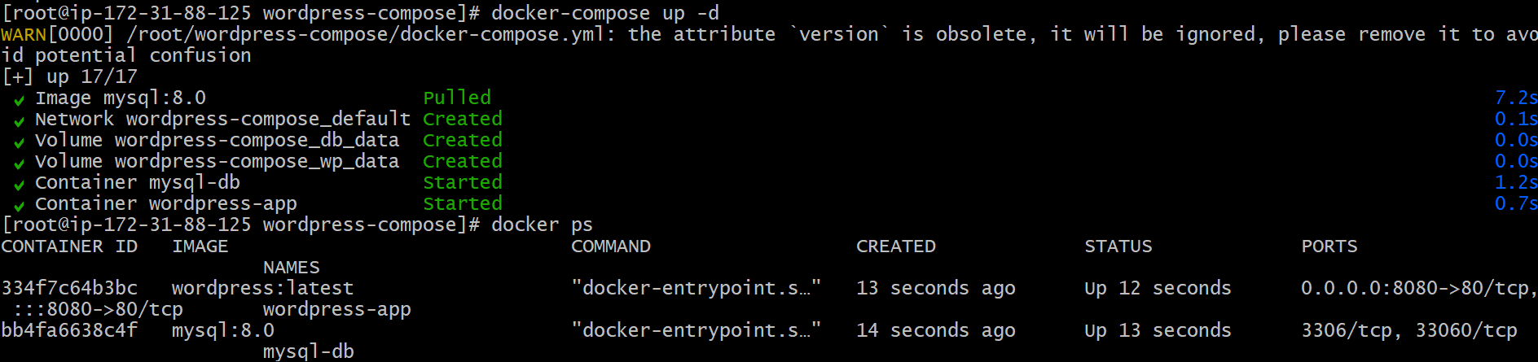

Step 5: Access WordPress

Open browser:

```
http://<EC2-Public-IP>:8080
```

Then complete the WordPress installation.

